# AWS Cloud

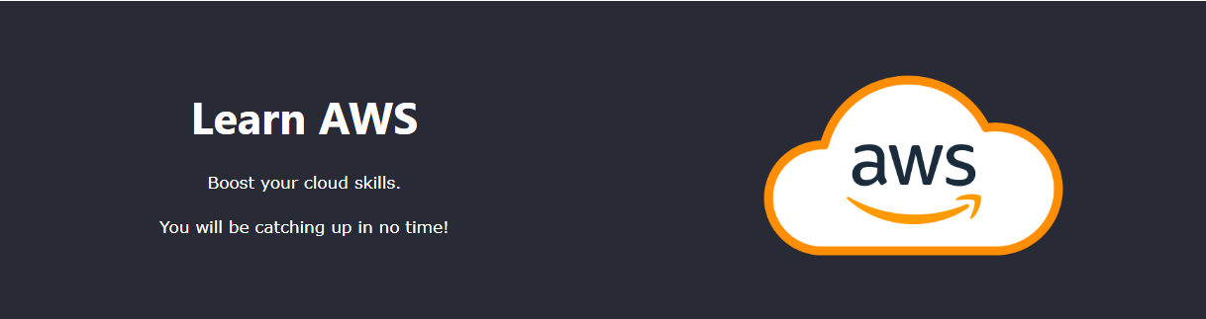

## **What is AWS Cloud?**

AWS (Amazon Web Services) is a cloud computing platform.

The first product (S3) was released in 2006.

AWS has grown a lot since then in both size and product range.

It is, to date, the largest cloud provider in the world.

## **Why Learn AWS Cloud?**

This skill offers many job opportunities.

AWS is one of the major cloud providers.

You can do everything in the AWS cloud.

## **The Client-Server Model**

The client-server model is an important concept in cloud computing.

It is about many clients using services from a centralized server.

## **What is the Client-Server Model?**

The Client-Server model is about a client that interacts and makes requests to a computer server.

A client is the way that the person interact with the server.

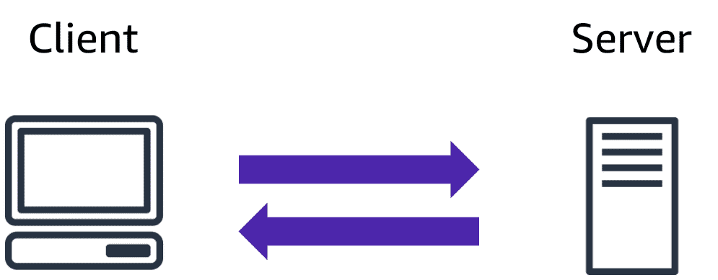

The server does tasks for the client and returns information.

## **Deployment Models**

There are three different kinds of deployment models:

* Cloud-based
* On-premises
* Hybrid

The models are different ways of accessing compute services - over the internet, locally, or in a combination.

## **Cloud-Based Deployment**

Everything runs in the cloud.

This model allows you to build new applications or move existing ones to the cloud.

There are different levels of services ranging from low to high.

The level of service has different requirements on your management, architecting, and infrastructure.

For example, a company might create an application consisting of virtual servers, databases, and networking components entirely based in the cloud.

## **On-Premises Deployment**

Deploy resources by using virtualization and resource management tools.

On-Premises Deployment is also known as private cloud deployment.

For example, you might have applications that run on technology that is fully kept in your on-premises data center.

Though this model is much like legacy IT infrastructure, its application management and virtualization technologies make it more effective.

## **Hybrid Deployment**

In a hybrid deployment, you connect cloud resources to an on-premises infrastructure.

This approach is relevant in many situations.

For example, you are working with sensitive data or are under specific government regulations.

## **Why Choose Cloud Computing?**

There are many reasons for going with the cloud.

Cloud computing enables benefits such as:

* Cost savings
* Security
* Scalability
* Flexibility